**Tab using React components**

**OUTPUT:**

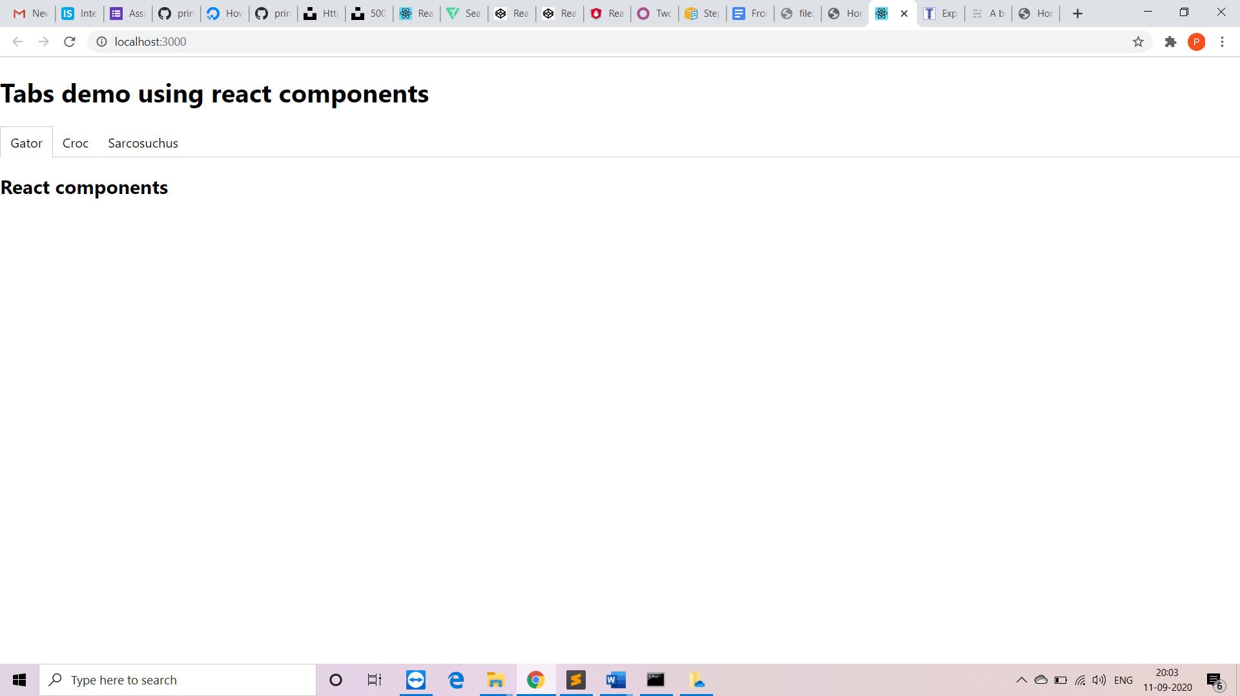

**App.js:**

import React from 'react';

import Tabs from "./components/Tabs";

import './App.css';

function App() {

return (

<div id="root">

<h1>Tabs demo using react components</h1>

<Tabs>

<div label="Gator">

<h2>React components</h2>

</div>

<div label="Croc">

<h2>Welcome</h2>

</div>

<div label="Sarcosuchus">

<h2>Hello</h2>

</div>

</Tabs>

</div>

);

}

export default App;

**Tab.js:**

import React, { Component } from 'react';

import PropTypes from 'prop-types';

class Tab extends Component {

static propTypes = {

activeTab: PropTypes.string.isRequired,

label: PropTypes.string.isRequired,

onClick: PropTypes.func.isRequired,

};

onClick = () => {

const { label, onClick } = this.props;

onClick(label);

}

render() {

const {

onClick,

props: {

activeTab,

label,

},

} = this;

let className = 'tab-list-item';

if (activeTab === label) {

className += ' tab-list-active';

}

return (

<li

className={className}

onClick={onClick}

>

{label}

</li>

);

}

}

export default Tab;

**tabs.js:**

import React, { Component } from 'react';

import PropTypes from 'prop-types';

import Tab from './Tab';

class Tabs extends Component {

static propTypes = {

children: PropTypes.instanceOf(Array).isRequired,

}

constructor(props) {

super(props);

this.state = {

activeTab: this.props.children[0].props.label,

};

}

onClickTabItem = (tab) => {

this.setState({ activeTab: tab });

}

render() {

const {

onClickTabItem,

props: {

children,

},

state: {

activeTab,

}

} = this;

return (

<div className="tabs">

<ol className="tab-list">

{children.map((child) => {

const { label } = child.props;

return (

<Tab

activeTab={activeTab}

key={label}

label={label}

onClick={onClickTabItem}

/>

);

})}

</ol>

<div className="tab-content">

{children.map((child) => {

if (child.props.label !== activeTab) return undefined;

return child.props.children;

})}

</div>

</div>

);

}

}

export default Tabs;